**Name: Shihab Muhtasim**

**ID:21301610**

**CSE421 lab2**

**Task 2**

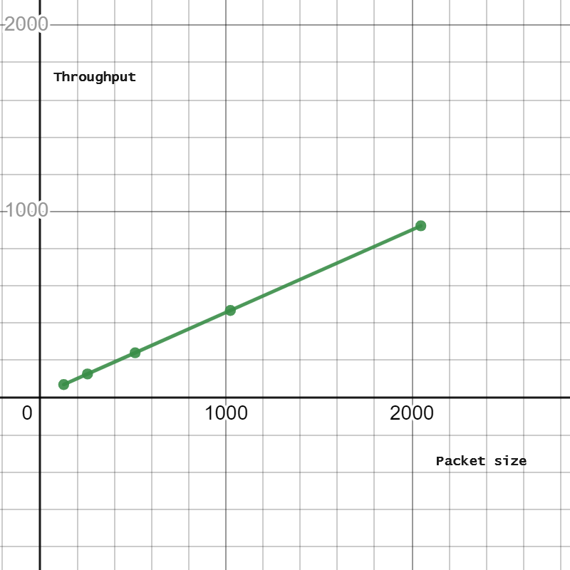

Here the x axis represents packet size and y axis represents the throughput. We observed that when 128 bytes was sent the throughput was 69.33 which then increased to 126.33 at packet size of 256 Bytes. Again when packet size was 512 the throughput became 240bps which increased to 467.54 at 1024 bytes packet size. Finally the throughput became 922.67 at 20-48 packet size. Hence, we can see the the throughput increases linearly with the size of data packet. The larger the data size the more is the throughput. It may be because with a constant speed of transmission, a larger data packet will need more time affecting the overall data rate and throughput.

**Outputs:**

